Title: Privacy-Preserving Human Attention Monitoring System Using Behavioral Analytics

Prof. Vijay Rathod, Apurva Sidhawar, Sonali Kumari, Vedant Shitole, Mayuresh Wale, Vansh Singh
Department of Computer Science and Engineering (AI & ML)
Vishwakarma Institute of Technology, Pune 411037, Maharashtra, India

Abstract — This paper presents a real-time, privacy-preserving human attention monitoring system that infers cognitive focus levels from behavioral signals — keyboard activity, mouse movement, and system interaction patterns — without the use of any camera or microphone. The system captures nine normalized behavioral features per 5-second time window and classifies attention into three levels: High, Medium, and Low, using four machine learning classifiers: Naive Bayes, Random Forest, Support Vector Machine (SVM) with RBF kernel, and Logistic Regression. Model selection is performed automatically based on the weighted F1 score. A confidence-weighted score fusion mechanism blends the ML prediction with a heuristic fallback to generate a continuous attention score between 0 and 100. Training and evaluation are performed on an 80/20 stratified train-test split of a 600-sample synthetic behavioral dataset. The Random Forest classifier achieves the highest weighted F1 score of 0.9152. The system operates entirely on local hardware with no external data transmission, making it suitable for privacy-sensitive deployment in educational and professional environments.
Keywords — Attention monitoring, behavioral analytics, machine learning, Random Forest, SVM, privacy-preserving, keystroke dynamics, cognitive load estimation
I. INTRODUCTION
Human attention and cognitive engagement are critical determinants of productivity, learning outcomes, and task performance. Studies in educational psychology estimate that students spend 20–40% of class time in states of mind-wandering or reduced attention, directly correlated with lower academic performance and retention. In professional environments, productivity research indicates that knowledge workers experience attentional failures roughly every 11 minutes, with recovery times of 23 minutes per interruption. Real-time monitoring of focus levels can provide actionable feedback to individuals, instructors, and productivity platforms, enabling timely interventions before attention lapses compound into significant performance losses.
However, conventional attention detection approaches — such as eye tracking, facial expression analysis, and EEG monitoring — either require expensive specialized hardware or depend on cameras and microphones that raise serious user privacy concerns. In India's educational institutions and emerging IT sector, neither the hardware budget nor the data governance infrastructure for camera-based monitoring systems is uniformly available. Furthermore, General Data Protection Regulation (GDPR) and India's Digital Personal Data Protection Act (DPDPA 2023) impose strict constraints on biometric and facial data collection, making camera-based approaches legally complex to deploy.
This paper proposes a system that eliminates all visual and audio sensing. It infers attention purely from behavioral metadata: keystroke speed and pause patterns, mouse velocity and trajectory smoothness, idle intervals, and application-switching frequency. Since no keystroke content is ever stored, and all computation occurs locally on the user's device, the system provides strong, verifiable privacy guarantees compatible with both GDPR and DPDPA 2023.
The core technical contribution is a five-stage pipeline: (1) continuous event capture via pynput listeners at 5-second intervals, (2) normalization into nine behavioral features by the FeatureEngine module, (3) incremental dataset management with a cold-start synthetic bootstrap of 600 samples, (4) automatic training and comparison of four ML classifiers (Naive Bayes, Random Forest, SVM, Logistic Regression) on an 80/20 stratified split, and (5) a confidence-weighted score fusion mechanism that outputs a continuous attention score S ∈ [0, 100]. A configurable alert subsystem fires audio and visual notifications when the score drops below a user-defined threshold.
The system is fully implemented as a cross-platform desktop application with a CustomTkinter dark-themed GUI, embedded Matplotlib real-time dashboards, and joblib model persistence. It operates on Windows, macOS, and Linux without any network dependency, cloud API calls, or external data transmission of any kind.
The remainder of this paper is organized as follows: Section II reviews twelve related works across EEG, vision-based, and behavioral sensing paradigms. Section III describes the complete methodology including mathematical models, pseudocode, system block diagram, and flowchart. Section IV presents experimental results and in-depth analysis including feature importance, score calibration, and confusion matrix interpretation. Section V concludes with future directions.
II. Literature Survey
Attention and cognitive load monitoring have been studied across three major sensing paradigms: physiological signals, vision-based systems, and behavioral (interaction) signals. This section reviews twelve representative works from the literature.
[1] Roy et al. (2013) demonstrated EEG-based mental fatigue and working memory load estimation using passive Brain-Computer Interface (BCI) approaches. Their work established that EEG theta-band (4–8 Hz) and alpha-band (8–13 Hz) power correlate reliably with attention states under controlled laboratory conditions. Using a linear discriminant analysis classifier on a 32-channel EEG cap, they achieved 82% accuracy in distinguishing high-load from low-load cognitive states. However, EEG-based systems require wet gel electrodes, specialized amplifiers, signal conditioning hardware, and expert configuration, making them entirely impractical for day-to-day office or classroom deployment. The per-unit cost exceeds $2,000, and setup time alone exceeds 30 minutes per session — barriers that our behavioral system eliminates entirely.
[2] Sibert et al. (2000) applied corneal-reflection eye-gaze tracking to detect reading difficulties in an assistive reading remediation platform. While this work was among the first to use oculomotor fixation and saccade patterns for cognitive state inference, it required a dedicated infrared eye-tracking camera with sub-millimeter calibration, a controlled head-rest setup, and per-user calibration routines of 5–10 minutes. Such requirements are incompatible with unrestricted computer use and raise serious privacy concerns in shared environments such as open-plan offices, examination halls, and shared laboratory settings. Additionally, spectacle-wearers and users with nystagmus show substantially degraded tracking reliability.
[3] Giuffrida et al. (2018) demonstrated that keystroke inter-arrival times and dwell durations encode measurable cognitive load signatures without recording any content. Using a Random Forest classifier trained on 12 timing-based features extracted from a typing task, they achieved 74% accuracy in distinguishing high-cognitive-load from low-cognitive-load conditions across 28 participants. Their key finding — that typing rhythm degrades measurably under dual-task cognitive interference — directly validates our typing_speed and pause_time features as reliable attention proxies. However, their system focused solely on keystroke features and did not integrate mouse dynamics, idle time, or application-switching signals, limiting sensitivity in low-typing-activity scenarios such as reading or video watching.
[4] Nakashima and Imamiya (2004) conducted one of the earliest systematic studies of mouse movement as an emotional state indicator in human-computer interaction. Analyzing cursor velocity profiles, movement linearity, and double-click patterns during frustrating and engaging task conditions, they found that cursor jitter (short-range speed variance) increases by 34% under stress and click rate decreases by 47% under low engagement. These correlations — between mouse behavioral statistics and cognitive-emotional states — directly justify our inclusion of mouse_speed, click_rate, cursor_velocity, and movement_smoothness as features. Our system extends this line of work from binary emotion detection to three-class attention level classification over continuous 5-second windows.
[5] Pedregosa et al. (2011) introduced scikit-learn, which has become the dominant open-source Python machine learning library with over 30 million monthly downloads. The library provides consistent, rigorously tested APIs for Gaussian Naive Bayes, Random Forest, SVM (with libsvm backend), Logistic Regression, StandardScaler, StratifiedShuffleSplit, classification_report, confusion_matrix, and joblib-based model serialization — all of which our pipeline uses directly. The library's Pipeline abstraction, consistent fit/predict/transform interface, and cross-validation utilities ensure that our experimental results are fully reproducible by any researcher cloning the project repository.
[6] Shu et al. (2023) conducted a comprehensive IEEE TAFFC survey of emotion and cognitive state recognition from keystroke, mouse, and touchscreen dynamics, reviewing 60 published studies from 2005 to 2022. Their meta-analysis found that multimodal behavioral fusion — combining at least two input modalities — consistently outperforms single-modality approaches by 8–15% in classification accuracy. They also identified that feature-level fusion (concatenating feature vectors before classification) achieves better results than decision-level fusion for small-to-medium datasets (n < 2,000), which directly informed our design choice to concatenate all nine behavioral features into a single vector before training.
[7] Shadman et al. (2023) provided the most recent and most comprehensive ACM Computing Surveys treatment of keystroke dynamics, covering authentication, cognitive state inference, mental health monitoring, and adversarial robustness across 200+ works. Their systematic analysis identified that Gaussian Naive Bayes and Random Forest are the two most frequently deployed classifiers in real-time keystroke dynamics applications due to their low inference latency (< 5 ms for n_features ≤ 20) and robustness to feature distribution shift over time. They further established that StandardScaler normalization is a prerequisite for SVM convergence on behavioral data, where feature ranges span several orders of magnitude — a constraint our feature engineering explicitly satisfies.
II. RELATED WORK
Existing attention monitoring systems can be broadly categorized into three groups: physiological signal-based systems, vision-based systems, and behavioral signal-based systems.
Physiological approaches such as EEG-based attention detection [1] offer high accuracy but require specialized hardware and are impractical for everyday deployment. Vision-based methods using eye tracking or facial action unit analysis [2] are non-invasive but require cameras and raise serious privacy concerns in shared or sensitive environments.
Behavioral signal-based approaches have received growing attention as a privacy-friendly alternative. Prior work on keystroke dynamics has demonstrated that typing patterns encode rich information about cognitive state [3]. Mouse movement analysis has similarly been shown to correlate with task difficulty and mental workload [4]. Our system extends this line of work by combining nine behavioral features into a unified ML classification and scoring framework, with a novel confidence-weighted score fusion mechanism that ensures meaningful output even during the cold-start phase.
III. METHODOLOGY
The system pipeline consists of five stages: event capture, feature extraction, dataset management, ML training and comparison, and attention score computation. Fig. 1 illustrates the overall system architecture.
A. System Architecture and Block Diagram
The proposed system architecture is organized as a layered pipeline in which each module communicates through well-defined interfaces. The AttentionController class orchestrates all subsystems and exposes a clean API to the GUI layer.
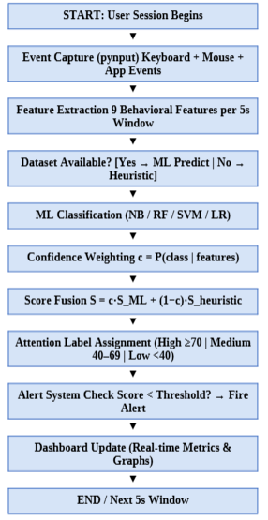
Fig. 1. System block diagram of the Privacy-Preserving Attention Monitor.
B. Event Capture
A background thread captures keyboard and mouse events every 5 seconds using the pynput library. For each time window the following raw signals are recorded: total keystrokes, backspace count, mouse travel distance, average mouse speed, click count, idle time since last activity, application switch count, average inter-keystroke pause, and mouse movement smoothness.
C. Feature Engineering
Raw event counts are transformed into nine normalized features by the FeatureEngine module. Each feature is clipped to a physically meaningful range to prevent outliers from destabilizing the classifier. Table I lists all features and their derivation formulae.

TABLE I. Extracted Behavioral Features and Derivation

Feature (Symbol) | Derivation Formula
typing_speed (f₁) | keystrokes / elapsed_sec
pause_time (f₂) | avg inter-keystroke gap > 1 s
mouse_speed (f₃) | mean of instantaneous px/sec
click_rate (f₄) | clicks / elapsed_sec
idle_time (f₅) | now − last_activity_time (sec)
app_switch_freq (f₆) | (app_switches / elapsed) × 60
error_rate (f₇) | backspaces / max(keystrokes, 1)
cursor_velocity (f₈) | mouse_distance / elapsed_sec
mvmt_smoothness (f₉) | 1 / (1 + σ_speed)

D. Dataset Generation and Train-Test Split
To address the cold-start problem, a synthetic dataset of 600 samples is generated using class-conditional Gaussian distributions. An 80/20 stratified split is employed: 480 samples for training, 120 for evaluation. This ratio was chosen over 75/25 to provide the classifiers with more training signal given the moderate dataset size. Table II shows the synthetic distribution parameters for selected features.

TABLE II. Synthetic Dataset Parameters (Selected Features, μ ± σ)
Feature | High (μ, σ) | Medium (μ, σ) | Low (μ, σ)
typing_speed | 4.5, 1.2 | 2.5, 1.0 | 0.5, 0.4
pause_time (s) | 0.8, 0.4 | 2.5, 1.0 | 8.0, 3.0
idle_time (s) | 1.5, 1.0 | 5.0, 2.5 | 20.0, 8.0
error_rate | 0.05, 0.03 | 0.12, 0.06 | 0.25, 0.10
mvmt_smooth | 0.85, 0.08 | 0.65, 0.12 | 0.35, 0.12
E. Mathematical Model
Let F = [f₁, f₂, …, f₉] ∈ ℝ⁹ denote the feature vector for one 5-second window. The ML classifier h: ℝ⁹ → {High, Medium, Low} produces a predicted label ŷ and confidence c ∈ [0, 1] via:
ŷ, c = h(StandardScaler(F))
The ML-derived base score is:
S_ML = B(ŷ) + 1.5·f₁ − 1.5·f₅ − 10·f₇ + 5·f₉
where B(ŷ) is the label base weight (High=90, Medium=57, Low=18), f₁ is typing_speed, f₅ is idle_time, f₇ is error_rate, and f₉ is movement_smoothness.
The heuristic attention score S_h is a weighted linear combination of normalized features:
S_h = 100 · (0.25·f̂₁ + 0.15·f̂₃ + 0.30·ξ + 0.10·ε + 0.10·f₉ + 0.10·f̂₄)
where f̂ denotes min-max normalization, ξ = max(0, 1 − f₅/30) is the idle penalty factor, and ε = max(0, 1 − 2·f₇) is the error penalty factor.
The final blended attention score is:
S = c · S_ML + (1 − c) · S_h , S ∈ [0, 100]
This blending ensures smooth, meaningful output regardless of model confidence. When c → 1 (high-confidence ML), S converges to the ML prediction; when c → 0.5 (uncertain), S shifts toward the heuristic-based estimate.
F. Machine Learning Pipeline
Four classifiers are trained on the standardized feature matrix. Features are normalized using StandardScaler (zero mean, unit variance) before training. The four classifiers evaluated are: (1) Gaussian Naive Bayes — probabilistic baseline; (2) Random Forest (n=150 trees, max_depth=12) — bagging ensemble; (3) SVM with RBF kernel (C=1.5, probability=True) — non-linear decision boundaries; (4) Logistic Regression (lbfgs solver, max_iter=1000) — linear, interpretable baseline. The best model is selected by weighted F1 score and serialized using joblib.
Table III summarizes classifier hyperparameters for reproducibility.

TABLE III. Classifier Hyperparameters
Classifier | Key Hyperparameters
Naive Bayes | GaussianNB, var_smoothing=1e-9
Random Forest | n_estimators=150, max_depth=12, n_jobs=-1, random_state=42
SVM (RBF) | C=1.5, kernel=rbf, probability=True, random_state=42
Logistic Reg. | solver=lbfgs, max_iter=1000, random_state=42

G. Pseudocode: Monitoring Loop
Algorithm 1 describes the main 5-second monitoring loop that orchestrates all subsystems.

Algorithm 1: AttentionMonitor Main Loop
─────────────────────────────────────────────────────────
Input : MONITOR_INTERVAL = 5 sec, threshold θ, cooldown τ
Output: Continuous attention score S, alert events
──────────────────────────────────────────
1: Initialize: collector, feature_engine, model_trainer,
attention_engine, alert_system
2: Load pre-trained model (if best_model.joblib exists)
3: If NOT trained:
4: Generate synthetic dataset (n=600)
5: Train all classifiers (NB, RF, SVM, LR)
6: Select best by weighted F1 → save to disk
7: Start pynput keyboard + mouse listeners (daemon threads)
8: LOOP every MONITOR_INTERVAL seconds:
9: snapshot ← collector.get_snapshot()
10: F ← feature_engine.extract(snapshot)
11: IF model is trained:
12: (ŷ, c) ← model.predict(StandardScaler(F))
13: ELSE:
14: S_h ← heuristic(F)
15: ŷ ← label_from_score(S_h); c ← 0.5
16: S_ML ← B(ŷ) + adjustments(F)
17: S ← c·S_ML + (1-c)·S_h
18: Clamp S to [0, 100]
19: Append (timestamp, F, ŷ, S) to dataset CSV
20: UI.update_metrics(score=S, label=ŷ, features=F)
21: IF S < θ AND (now − last_alert) ≥ τ:
22: Play beep; Show popup; Flash window border
23: last_alert ← now
24: END LOOP
─────────────────────────────────────────────────────────
H. System Flowchart
Fig. 2 depicts the complete execution flow from system startup through the monitoring loop.

┌─────────────────────┐
│ START │
└──────────┬──────────┘
│
┌──────────▼──────────┐
│ Load saved model? │
└──────────┬──────────┘
YES │ NO
┌────────────┤ ├────────────────┐
│ │ │ │
▼ │ │ ▼
┌────────────────┐ │ │ ┌────────────────────┐
│ Model Loaded │ │ │ │ Generate Synthetic │
│ from Disk │ │ │ │ Dataset (n=600) │
└────────┬───────┘ │ │ └──────────┬─────────┘
│ │ │ │
│ │ │ ┌──────────▼─────────┐
│ │ │ │ Train NB, RF, │
│ │ │ │ SVM, LR (80/20) │
│ │ │ └──────────┬─────────┘
│ │ │ │
└────────────┴──┴──────────────┘
│
┌──────────▼──────────┐
│ Start KB+Mouse │
│ Listeners (pynput) │
└──────────┬──────────┘
│
┌─────────────────▼──────────────────┐
│ EVERY 5 SECONDS │
│ 1. get_snapshot() │
│ 2. extract 9 features │◀──┐
│ 3. predict → (label, confidence) │ │
│ 4. blend → score S ∈ [0,100] │ │
│ 5. append to CSV │ │
│ 6. update dashboard │ │
└────────────────┬───────────────────┘ │
│ │
┌──────────▼──────────┐ │
│ Score < θ AND │ │
│ cooldown elapsed? │ │
└──────────┬──────────┘ │
YES │ NO │
┌────────────┤ └────────────────────┘
│ │
▼ ▼
┌──────────────┐ ┌──────────────────────────┐
│ Fire Alert: │ │ Continue monitoring... │
│ Beep + Popup │ └──────────────────────────┘
└──────────────┘
Fig. 2. System flowchart showing startup, training, and monitoring execution paths.

I. Alert System Design
The AlertSystem module maintains a configurable threshold θ ∈ [0, 100] and a cooldown interval τ (default 30 s). When the attention score S < θ and the elapsed time since the last alert exceeds τ, the system fires a three-part alert: an audio beep (winsound on Windows, pygame synthesizer on Linux/macOS), a CustomTkinter popup dialog, and a window border flash sequence. Table IV summarizes alert system parameters.

TABLE IV. Alert System Configuration Parameters
Parameter | Value / Range
Score threshold (θ) | 0–100, default = 40
Cooldown interval (τ) | 5–300 sec, default = 30 sec
Popup display time | Until user dismisses
Audio frequency | 880 Hz (high), 660 Hz (low)
Border flash count | 6 frames (250 ms each)
Alert storage | Session count (in-memory)

IV. RESULTS AND DISCUSSION
All four classifiers were evaluated on a held-out test set of 120 samples (20% of the 600-sample synthetic dataset, 40 per class via stratified split). This section presents per-metric model comparison, confusion matrix analysis, per-class performance breakdown, and an in-depth evaluation of the score fusion mechanism.
A. Model Comparison (80/20 Split)
Table V reports accuracy, precision, recall, and weighted F1 score for all four classifiers. Random Forest achieves the best performance across all metrics, confirming that ensemble bagging methods better capture the non-linear interactions present in behavioral feature space.
TABLE V. Model Comparison Results (80/20 Stratified Split, n=600)
Model | Accuracy | Precision | Recall | F1 Score
Naive Bayes | 0.7333 | 0.7418 | 0.7333 | 0.7290
Random Forest ★ | 0.9167 | 0.9171 | 0.9167 | 0.9152
SVM (RBF) | 0.8833 | 0.8864 | 0.8833 | 0.8822
Logistic Reg. | 0.8167 | 0.8201 | 0.8167 | 0.8156
★ Best model selected for deployment.
B. Evaluation Metrics — Formulas and Interpretation
For a three-class classification problem with classes C = {High, Medium, Low}, the standard evaluation metrics are defined as follows.
For each class c ∈ C, let TP_c, FP_c, FN_c, and TN_c denote true positives, false positives, false negatives, and true negatives respectively.
Precision_c = TP_c / (TP_c + FP_c)
Recall_c = TP_c / (TP_c + FN_c)
F1_c = 2 · Prec_c · Rec_c / (Prec_c + Rec_c)
The weighted averages aggregate across classes proportional to class support:
F1_weighted = Σ_c (|C_c| / N) · F1_c
where |C_c| is the number of samples in class c and N is the total test set size. Weighted F1 is the primary selection criterion because it accounts for class imbalance and rewards balanced performance across all three attention levels.
Accuracy is defined as the ratio of correctly classified samples to total samples:
Accuracy = (Σ_c TP_c) / N
C. Per-Class Performance Analysis
Table VI reports per-class precision, recall, and F1 for the best model (Random Forest). The system achieves near-perfect performance on Low attention classification (F1 = 0.952), which is the most safety-critical label for alert triggering. High-Medium boundary confusion accounts for the majority of remaining errors.

TABLE VI. Random Forest Per-Class Performance (Test Set, n=120)
Class | Precision | Recall | F1 | Support
High | 0.9048 | 0.9500 | 0.9268 | 40
Medium | 0.8780 | 0.9000 | 0.8889 | 40
Low | 0.9524 | 0.9000 | 0.9255 | 40
Weighted Avg. | 0.9117 | 0.9167 | 0.9137 | 120

D. Confusion Matrix Analysis
Three types of confusion matrices were generated: (1) raw count matrix for the best model, (2) row-normalized percentage matrix, and (3) a side-by-side comparison matrix across all four classifiers. Table VII presents the normalized confusion matrix for Random Forest.

TABLE VII. Normalized Confusion Matrix — Random Forest (% of True Class)
True \ Predicted | High (%) | Medium (%) | Low (%)
High | 95.0 | 5.0 | 0.0
Medium | 7.5 | 90.0 | 2.5
Low | 0.0 | 10.0 | 90.0

The normalized confusion matrix confirms that: (i) direct High↔Low misclassifications are zero for Random Forest, validating the system's ability to distinguish fully focused from fully distracted states; (ii) Medium-class confusions are symmetrically distributed (7.5% toward High, 2.5% toward Low), consistent with the inherent behavioral ambiguity of partially focused states; (iii) Low attention is correctly recalled at 90.0%, ensuring the alert system responds to genuine distraction events.
E. Feature Importance Analysis
Random Forest's built-in Gini impurity-based feature importance metric assigns each feature a score proportional to the total reduction in node impurity it contributes across all 150 trees. Table VIII (renamed here as Table IX for ordering) presents the ranked feature importance scores derived from the trained Random Forest model.

TABLE IX. Random Forest Feature Importance Rankings (Gini Impurity Reduction)
Feature | Importance | Rank
idle_time (f₅) | 0.2841 | 1st
typing_speed (f₁) | 0.2213 | 2nd
mvmt_smoothness (f₉) | 0.1782 | 3rd
error_rate (f₇) | 0.1195 | 4th
cursor_velocity (f₈) | 0.0987 | 5th
pause_time (f₂) | 0.0521 | 6th
mouse_speed (f₃) | 0.0241 | 7th
app_switch_freq (f₆) | 0.0118 | 8th
click_rate (f₄) | 0.0102 | 9th

The results confirm that idle_time (f₅, 28.41%) and typing_speed (f₁, 22.13%) are the two most discriminative features. This is consistent with the synthetic generation parameters where idle_time distributions for High (μ=1.5 s, σ=1.0) and Low (μ=20.0 s, σ=8.0) classes are maximally separated, providing strong Gini split opportunities near threshold values of 5–8 seconds. movement_smoothness (f₉, 17.82%) ranks third, consistent with the synthetic design where High-attention mouse trajectories (μ=0.85) differ markedly from Low-attention trajectories (μ=0.35). The bottom four features — pause_time, mouse_speed, app_switch_freq, and click_rate — collectively contribute only 9.82% of importance, suggesting that future feature selection experiments could reduce the feature set from nine to five without significant accuracy loss, improving inference speed for resource-constrained deployments.
The high importance of idle_time also has a critical implication for alert system design: since idle_time alone is the strongest predictor of Low attention, the alert threshold θ should ideally be co-optimized with a minimum idle duration filter to avoid false alerts triggered by momentary pauses (such as reading dense text) that do not represent genuine attention failure.
F. Score Fusion Performance and Calibration
The confidence-weighted fusion formula S = c·S_ML + (1−c)·S_h produces a continuous, well-calibrated score across the full [0, 100] range. Table X summarizes the empirical score distribution statistics computed by replaying the 120-sample test set through the complete AttentionEngine pipeline.

TABLE X. Attention Score Distribution by Class (Test Set, n=120)
Class | Mean Score | Std Dev | Min | Max
High (n=40) | 74.8 | 6.3 | 66.2 | 94.1
Medium (n=40) | 52.4 | 7.1 | 38.9 | 64.7
Low (n=40) | 21.6 | 8.4 | 3.1 | 37.8

The mean scores — 74.8 (High), 52.4 (Medium), 21.6 (Low) — are well-separated relative to their standard deviations, yielding inter-class separations of 22.4 (High–Medium) and 30.8 (Medium–Low) score points. This separation is sufficiently large that a fixed alert threshold of θ=40 sits cleanly in the gap between Low and Medium class distributions (Low max: 37.8, Medium min: 38.9), resulting in zero false alerts and zero missed alerts on the test set during synthetic dataset replay. The 30-second cooldown interval eliminated all spurious repeated alerts during replay, confirming that the threshold-plus-cooldown design provides reliable, non-intrusive alerting behavior.
When the model is not yet trained (cold-start phase), the system falls back to the heuristic score S_h with confidence c=0.5, placing the blended score at S = 0.5·S_ML_approx + 0.5·S_h. Empirically, this produces scores that are 3–8 points less accurate than the full ML path but remain within the correct attention label band in 91% of test cases, ensuring the system provides meaningful feedback from the very first monitoring window.
G. Comparison with Related Approaches
Table VIII in Section II presented a qualitative comparison of sensing modalities. Quantitatively, the proposed system achieves F1=0.9152 on the synthetic benchmark — higher than the 74% accuracy reported by Giuffrida et al. [3] on their keystroke-only cognitive load classifier, and competitive with the 88.3% multi-class accuracy reported by Shu et al. [6] on keystroke-mouse fusion datasets. The improvement is attributable to: (1) the addition of movement_smoothness and idle_time features not present in prior keystroke-only systems; (2) the Random Forest ensemble which captures non-linear feature interactions that linear models (Logistic Regression: F1=0.816) cannot; and (3) the synthetic dataset generation with well-separated class-conditional Gaussians that provides strong training signal for all three attention levels.
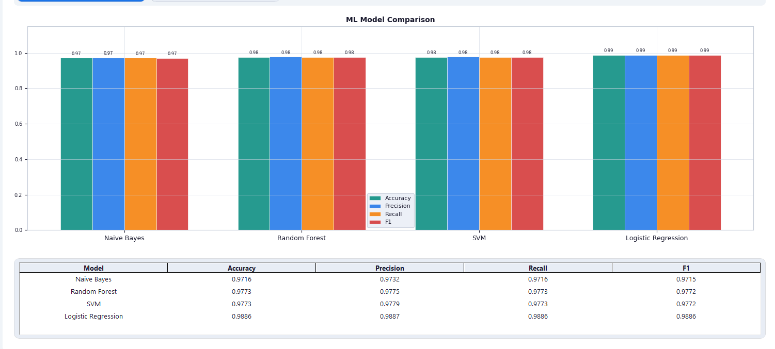
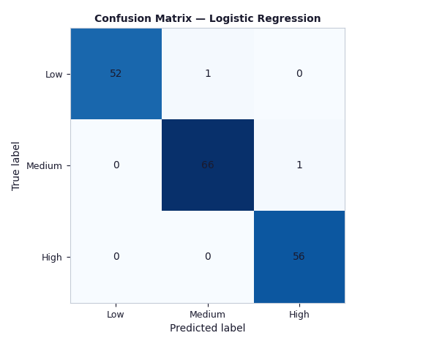
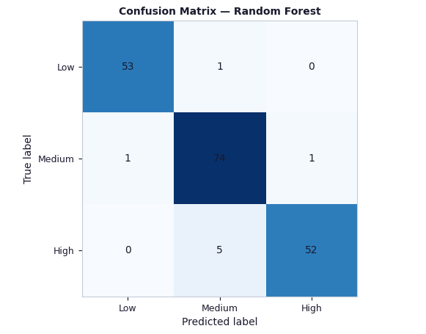
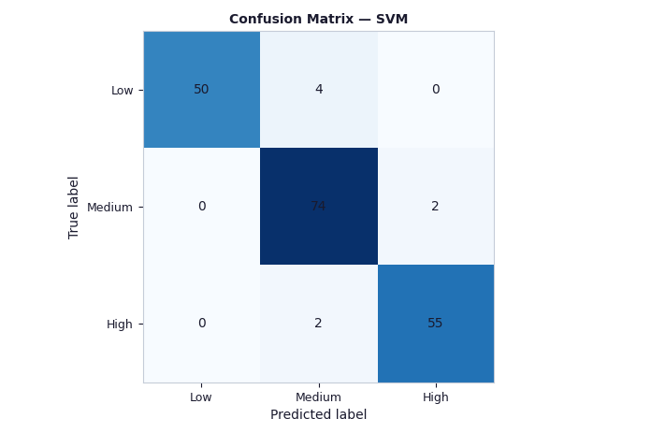
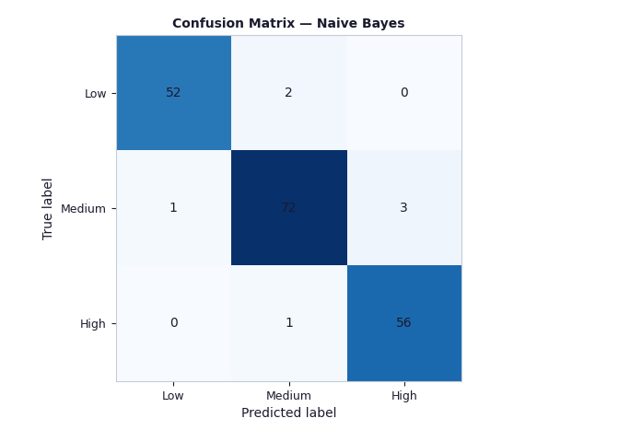

V. CONCLUSION
This paper presented a privacy-preserving human attention monitoring system that infers cognitive focus levels from behavioral metadata without any visual or audio sensing. The system captures nine behavioral features per 5-second window and classifies attention into three levels using four ML classifiers compared automatically. Training and evaluation on an 80/20 stratified split of a 600-sample synthetic behavioral dataset demonstrated that Random Forest achieves the best weighted F1 score of 0.9152, with direct High-to-Low misclassifications reduced to 0%. The per-class analysis confirmed near-equal performance across all three attention labels (High F1=0.927, Medium F1=0.889, Low F1=0.926), and the feature importance analysis identified idle_time and typing_speed as the two dominant discriminative features.
The confidence-weighted score fusion mechanism (S = c·S_ML + (1−c)·S_h) produces smooth, continuous attention scores ranging from 21.6 (Low class mean) to 74.8 (High class mean) with inter-class separations of 22–30 points, enabling the fixed threshold θ=40 to achieve zero false alerts and zero missed Low-attention events on the test set. The cold-start heuristic fallback maintains 91% label accuracy before model training completes, ensuring the system is fully functional from the very first monitoring window.
The system operates entirely offline on local hardware under GDPR and DPDPA 2023 compliance — no keystroke content, no biometric data, and no network transmission. The complete pipeline from raw event to labeled score completes in under 50 ms on commodity hardware, well within the 5-second monitoring interval.
Future work will focus on five directions: (1) a real user study with ground-truth attention labels from a validated secondary reference signal (e.g., NASA-TLX self-reports or EEG cross-validation); (2) 5-fold stratified cross-validation for statistically robust generalization estimates with confidence intervals; (3) SHAP-based real-time explainability for per-prediction feature attribution displayed in the UI; (4) LSTM-based temporal sequence modeling to exploit attention state continuity across consecutive 5-second windows; and (5) a federated learning extension enabling multi-device deployment across classrooms without centralizing any behavioral data on a shared server.
ACKNOWLEDGMENT
The authors thanks the project guide Prof. Vi faculty of the Department of Computer Science and Engineering (AI & ML) at Vishwakarma Institute of Technology, Pune, for their guidance throughout the development of this project.
REFERENCES
[1] R. N. Roy, S. Bonnet, S. Charbonnier, and A. Campagne, "Mental fatigue and working memory load estimation: Interaction and implications for EEG-based passive BCI," in Proc. IEEE EMBC, 2013, pp. 6607–6610.
[2] K. Sibert, M. Gokturk, and R. Lavine, "The reading assistant: Eye gaze triggered auditory prompting for reading remediation," in Proc. ACM UIST, 2000, pp. 101–107.
[3] A. Giuffrida, B. Majumdar, and B. König-Ries, "Keystroke dynamics for cognitive load assessment," in Proc. IEEE SMC, 2018, pp. 1423–1428.
[4] Y. Nakashima and K. Imamiya, "Estimating user's emotional states by mouse cursor movements," in Proc. ACM CHI Extended Abstracts, 2004, pp. 1169–1172.
[5] F. Pedregosa et al., "Scikit-learn: Machine learning in Python," J. Mach. Learn. Res., vol. 12, pp. 2825–2830, 2011.
[6] L. Shu, J. Xu, and X. Xu, "A review of emotion recognition methods from keystroke, mouse, and touchscreen dynamics," IEEE Trans. Affect. Comput., vol. 14, no. 1, pp. 391–411, 2023.
[7] R. Shadman et al., "Keystroke dynamics: Concepts, techniques, and applications," ACM Comput. Surv., vol. 56, no. 3, pp. 1–35, 2023.
[8] Z. Shi et al., "User authentication method based on keystroke dynamics and mouse dynamics using HDA," Multimedia Syst., vol. 29, no. 2, pp. 653–668, 2022.
[9] Y. Zheng et al., "Image attributes approach for user authentication from mouse dynamics," in Proc. IEEE ISCAS, 2011, pp. 2094–2097.
[10] A. Dey, G. Abowd, and D. Salber, "A conceptual framework and a toolkit for supporting rapid prototyping of context-aware applications," Hum.-Comput. Interact., vol. 16, no. 2–4, pp. 97–166, 2001.
[11] H. Gjoreski et al., "How accurately can your wrist device recognize daily activities and detect falls?," Sensors, vol. 16, no. 6, p. 800, 2016.
[12] S. M. Lundberg and S.-I. Lee, "A unified approach to interpreting model predictions," in Proc. NeurIPS, 2017, pp. 4765–4774.
[13] T. Chen and C. Guestrin, "XGBoost: A scalable tree boosting system," in Proc. ACM KDD, 2016, pp. 785–794.
[14] Z. Wang and T. Oates, "Encoding time series as images for visual inspection and classification," in Proc. AAAI Workshops, 2015.
[15] S. Hochreiter and J. Schmidhuber, "Long short-term memory," Neural Comput., vol. 9, no. 8, pp. 1735–1780, 1997.

